The Original  B.A.T.I.  Training |  | Eureka – College of the Sequoias Public Training Center Hosts 40-hour BATI Investigative Interview & Interrogation Training
“Recipient of the CA Governor’s Award for Excellence in Peace Officer Training” |  | 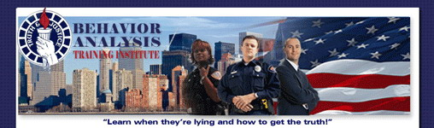  Investigative Interview & Interrogation  College of the Sequoias Public Training Center  7351 Tomkins Hill Rd, Eureka, Ca 95501  August 7-11, 2023/ 0800-1700 hrs. Tuition: $575  CA POST APPROVED PLAN IV / 9590-31445-23026  CA STC 10052-079829 – Fire Marshall Approved  BATI has trained over 36,000 students in the past 37 years. BATI is recognized as one of the Premier Investigative Interview & Interrogation Classes in California. This class is open to all sworn and non-sworn Investigators, Parole, Probation, Fire Investigators per State Fire Marshal, Polygraphers, Background Investigators, Internal Affairs and Patrol Officers are just a small example. If you are conducting Interviews, you want to take this class.  Interviewing: Interview Psychology, the BATI Interview Protocol, De-Escalation and Rapport building, Open-ended questioning vs Direct Questions, Methods for Detecting Deception, Credibility Assessment Interviewing, Understanding Victims, Witness, Suspect Truth Telling Style.  Interrogation: Interrogator Demeanor and Protocol, The Accusation Approach, Defeating Defensive Tactics, Theme Development and Delivery, Importance of Alternative Questions, Taking the Confession, Protecting Against False Confession, Finishing the Investigation. Students will be involved in conducting 5 Interrogations in the Class.  Register online: www.LieDetection.com  Behavior Analysis Training, Inc.  P.O Box 5168  Auburn, CA 95604  Phone: 530-432-0283  Email: liedetection@comcast.net

