The Original  B.A.T.I.  Training |  | Redding Shield Regional Training Consortium Hosts 40-hour BATI Investigative Interview & Interrogation Training
September 26, 2022 | Volume 1, Number 1
“Recipient of the CA Governor’s Award for Excellence in Peace Officer Training” |  | 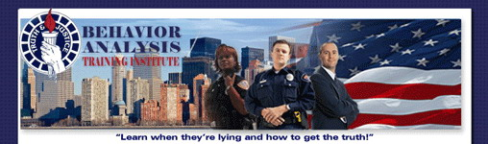  Investigative Interview & Interrogation  Redding Shield Regional Training Consortium  4300 Caterpillar Rd., Redding Ca 96001  March 6-10, 2023/ 0800-1700 hrs. Tuition: $575.00  CA POST APPROVED PLAN IV / 9590-31445-22057– NV POST P2580003 CA STC 10052-079829  BATI has trained over 32,000 students in the past 35 years. BATI is recognized as one of the Premier Investigative Interview & Interrogation Classes in California. This class is open to all sworn and non-sworn Investigators, Parole, Probation, Fire Investigators per State Fire Marshal, Polygraphers, Background Investigators, Internal Affairs and Patrol Officers are just a small example. If you are conducting Interviews, you want to take this class.  Interviewing: Interview Psychology, the BATI Interview Protocol, De-Escalation and Rapport building, Open-ended questioning vs Direct Questions, Methods for Detecting Deception, Credibility Assessment Interviewing, Understanding Victims, Witness, Suspect Truth Telling Style.  Interrogation: Interrogator Demeanor and Protocol, The Accusation Approach, Defeating Defensive Tactics, Theme Development and Delivery, Importance of Alternative Questions, Taking the Confession, Protecting Against False Confession, Finishing the Investigation. Students will be involved in conducting 5 Interrogations in the Class.  Register online: www.LieDetection.com  Behavior Analysis Training, Inc.  P.O Box 5168  Auburn, CA 95604  Phone: 530-432-0283  Email: liedetection@comcast.net

