The Original  B.A.T.I.  Training |  | Santa Clara Sheriff Richey Training Center Hosting 1 Day Interviewing for First Responders/Refresher Training
May 1, 2023 | Volume 1, Number 1
“Recipient of the CA Governor’s Award for Excellence in Peace Officer Training” |  | 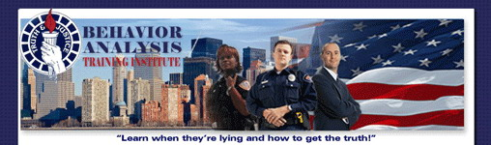  Interviewing for First Responders  Richey Training Center 155 W. Hedding Street, San Jose, Ca. 95110 Tuition: $138  CA POST APPROVED Plan IV / 9590-31434-23003  October 5, 2023, 2023 – 0800 - 1700 hrs.  - Developing Rapport Quickly  - Securing an Uncontaminated Statement  - Conducting a Proper Follow-up Interview  - Detecting Deception through Physical and Verbal Behaviors  This course is for anyone responsible for initial or follow-up interviews in any type of investigation. Many prior BATI Students are using this training as a refresher. Students will learn a new methodology of securing proper statements from victims, witnesses and suspects that will assist in successful case resolution. If your interviews are in person or over the phone this training is for you! It incorporates new concepts of information retrieval that are conducted in an effective, legal and ethical manner.  The words that people use are extremely important. They reveal true feelings and relationships between the speaker and other people or things within their statement. Knowing how to decipher a person’s linguistic code gives the interviewer a tactical advantage. Some say it is the best way to detect deception which is helpful in the interview room or in the field for officer safety.  Register Online www.LieDetection.com  Behavioral Analysis Training Inc.  P.O Box 5168  Auburn, CA 95604  Phone/Fax: 530-432-0283  Email: liedetection@comcast.net

